**EXISTING SYSTEM:**

Consider an entrepreneur who is evaluating a business opportunity

for a market in a multiperiod setting. The state of bathe market—whether the market has a positive or negative outlook for the entrepreneur’s opportunity—depends on a variety of external market factors such as economic, governmental, social, and regulatory that may not be directly observable and may change over time. Furthermore, the entrepreneur’s risk preference and operational shortages of one or more of 4Rs (i.e., internal constraints) influence the entrepreneur’s ability to observe the state of the market and take control over market changes. To exemplify the impact of an external factor on opportunity assessment, we offer a simulated example of an entrepreneurial venture in a developing industry (e.g., clean energy). The entrepreneur may not have established know-how of external market regulations and lobbying practices for the technology (i.e., shortage of external regulations). Although the new venture’s investors may provide some policy and regulatory assistance, the regulations for an emerging technology may

be transient, which is likely to result in a hidden market. Therefore, he or she might not be able to fully evaluate the true economic outlook—positive or negative—without understanding the regulatory conditions, particularly among the rapidly changing laws surrounding energy. Information about the state of regulations and policy is needed to evaluate the valuation of the market for the clean energy innovation through hiring legal services, lobbying practices and active participation

in discussions about pending regulations The entrepreneur in our model gathers information about the market by allocating her/his total funds *X* across a portfolio of *i*nvestments in *f* independent external market factors over T *P*eriods. To maximize potential returns of a business opportunity, a resource-constrained entrepreneur could invest small amounts of his/her resources, while minimizing risk exposure . For example, prior to Turkey’s passage of a renewable energy law in 2005, most clean energy entrepreneurs made relatively marginal investments to reflect the market’s appetite for solar. The level of information, as denoted by *νjk*

*∈* [0*,* 1],

about the market factor *j ∈ {*1*, . . . , f}* depends on investment

*k ∈ {*1*, . . . , m}*, whose return provides information about factor

*j*. Subsequently, the investment returns form the state values of an observable process as characterized by the observed market factors.

.

**DISADVANTAGES:**

* More are less is probability based
* In this process is not secured for the data analyzing system
* 100 percentage is not successful

.

**PROPOSED SYSTEM:**

Although our model has enabled us to examine a new method of evaluating a hidden market process, several assumptions, limitations, and related extensions to this research need to be acknowledged. First, our key assumptions pose inherent limitations on our model. For example, although our assumption about an exogenous and independent change in the valuation of investments does not necessarily change our insights, the relaxation of this assumption could lead to more profound insights into the market. Second, a DP allows for nonlinearity, path-dependence, and unpredictability. These properties are important,

assuming that a Markov model is a close representation of decision-making in real-world entrepreneurial contexts. Third, we did not account for dependence between market factors (i.e., spill-over effects within the entrepreneur’s accumulated information) and selection bias for market factors. Nor did we check the validity of the received information, which raises the question of how an entrepreneur can ensure that he/she is inputting the right information. It would be fruitful for researchers to examine both the selection and validation of market factors (e.g., financial) that we investigated, as well as factors that we overlooked (e.g., political and regulatory). Finally, it would be helpful to examine how entrepreneurs adapt to market realities while their internal processes and technologies evolve. These areas, if explored, could provide important insights for the fields of strategy, OM, and entrepreneurship.

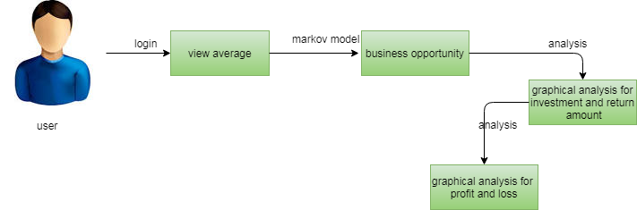

**ADVANTAGES**

* Business opportunity calculated is easily
* Time is save for this process
* Money is not waste in this analysis
* Most secured process